

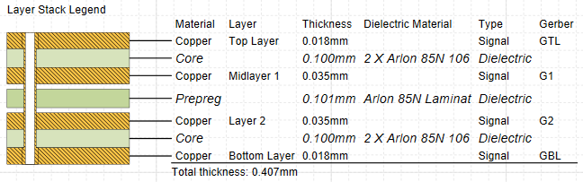

Total thickness 0.480 +/- 0.10mm. Material; Arlon 85N (Polyamide) -- IPC-4101/41. Copper foil thickness layer GTL and GBL (excluding copper plating) Cu plating in accordance with IPC-601X Hole Cu plating tables.

Note: Finished thickness may be less than specified (Depending on inner layer copper coverage), leading to a corresponding reduction of finished total thickness.

